Periandri_Anthony_Assignment 5

2025-06-23

library(cluster)  
library(factoextra)

## Loading required package: ggplot2

## Welcome! Want to learn more? See two factoextra-related books at https://goo.gl/ve3WBa

library(proxy)

##   
## Attaching package: 'proxy'

## The following objects are masked from 'package:stats':  
##   
## as.dist, dist

## The following object is masked from 'package:base':  
##   
## as.matrix

library(mclust)

## Package 'mclust' version 6.1.1  
## Type 'citation("mclust")' for citing this R package in publications.

library(dplyr)

##   
## Attaching package: 'dplyr'

## The following objects are masked from 'package:stats':  
##   
## filter, lag

## The following objects are masked from 'package:base':  
##   
## intersect, setdiff, setequal, union

cereals <- read.csv("Cereals.csv", stringsAsFactors = TRUE)  
cereals_clean <- na.omit(cereals)  
##show dataa  
print(cereals_clean)

## name mfr type calories protein fat sodium  
## 1 100%_Bran N C 70 4 1 130  
## 2 100%_Natural_Bran Q C 120 3 5 15  
## 3 All-Bran K C 70 4 1 260  
## 4 All-Bran_with_Extra_Fiber K C 50 4 0 140  
## 6 Apple_Cinnamon_Cheerios G C 110 2 2 180  
## 7 Apple_Jacks K C 110 2 0 125  
## 8 Basic_4 G C 130 3 2 210  
## 9 Bran_Chex R C 90 2 1 200  
## 10 Bran_Flakes P C 90 3 0 210  
## 11 Cap'n'Crunch Q C 120 1 2 220  
## 12 Cheerios G C 110 6 2 290  
## 13 Cinnamon_Toast_Crunch G C 120 1 3 210  
## 14 Clusters G C 110 3 2 140  
## 15 Cocoa_Puffs G C 110 1 1 180  
## 16 Corn_Chex R C 110 2 0 280  
## 17 Corn_Flakes K C 100 2 0 290  
## 18 Corn_Pops K C 110 1 0 90  
## 19 Count_Chocula G C 110 1 1 180  
## 20 Cracklin'_Oat_Bran K C 110 3 3 140  
## 22 Crispix K C 110 2 0 220  
## 23 Crispy_Wheat_&_Raisins G C 100 2 1 140  
## 24 Double_Chex R C 100 2 0 190  
## 25 Froot_Loops K C 110 2 1 125  
## 26 Frosted_Flakes K C 110 1 0 200  
## 27 Frosted_Mini-Wheats K C 100 3 0 0  
## 28 Fruit_&_Fibre_Dates,_Walnuts,_and_Oats P C 120 3 2 160  
## 29 Fruitful_Bran K C 120 3 0 240  
## 30 Fruity_Pebbles P C 110 1 1 135  
## 31 Golden_Crisp P C 100 2 0 45  
## 32 Golden_Grahams G C 110 1 1 280  
## 33 Grape_Nuts_Flakes P C 100 3 1 140  
## 34 Grape-Nuts P C 110 3 0 170  
## 35 Great_Grains_Pecan P C 120 3 3 75  
## 36 Honey_Graham_Ohs Q C 120 1 2 220  
## 37 Honey_Nut_Cheerios G C 110 3 1 250  
## 38 Honey-comb P C 110 1 0 180  
## 39 Just_Right_Crunchy__Nuggets K C 110 2 1 170  
## 40 Just_Right_Fruit_&_Nut K C 140 3 1 170  
## 41 Kix G C 110 2 1 260  
## 42 Life Q C 100 4 2 150  
## 43 Lucky_Charms G C 110 2 1 180  
## 44 Maypo A H 100 4 1 0  
## 45 Muesli_Raisins,_Dates,_&_Almonds R C 150 4 3 95  
## 46 Muesli_Raisins,_Peaches,_&_Pecans R C 150 4 3 150  
## 47 Mueslix_Crispy_Blend K C 160 3 2 150  
## 48 Multi-Grain_Cheerios G C 100 2 1 220  
## 49 Nut&Honey_Crunch K C 120 2 1 190  
## 50 Nutri-Grain_Almond-Raisin K C 140 3 2 220  
## 51 Nutri-grain_Wheat K C 90 3 0 170  
## 52 Oatmeal_Raisin_Crisp G C 130 3 2 170  
## 53 Post_Nat._Raisin_Bran P C 120 3 1 200  
## 54 Product_19 K C 100 3 0 320  
## 55 Puffed_Rice Q C 50 1 0 0  
## 56 Puffed_Wheat Q C 50 2 0 0  
## 57 Quaker_Oat_Squares Q C 100 4 1 135  
## 59 Raisin_Bran K C 120 3 1 210  
## 60 Raisin_Nut_Bran G C 100 3 2 140  
## 61 Raisin_Squares K C 90 2 0 0  
## 62 Rice_Chex R C 110 1 0 240  
## 63 Rice_Krispies K C 110 2 0 290  
## 64 Shredded_Wheat N C 80 2 0 0  
## 65 Shredded_Wheat_'n'Bran N C 90 3 0 0  
## 66 Shredded_Wheat_spoon_size N C 90 3 0 0  
## 67 Smacks K C 110 2 1 70  
## 68 Special_K K C 110 6 0 230  
## 69 Strawberry_Fruit_Wheats N C 90 2 0 15  
## 70 Total_Corn_Flakes G C 110 2 1 200  
## 71 Total_Raisin_Bran G C 140 3 1 190  
## 72 Total_Whole_Grain G C 100 3 1 200  
## 73 Triples G C 110 2 1 250  
## 74 Trix G C 110 1 1 140  
## 75 Wheat_Chex R C 100 3 1 230  
## 76 Wheaties G C 100 3 1 200  
## 77 Wheaties_Honey_Gold G C 110 2 1 200  
## fiber carbo sugars potass vitamins shelf weight cups rating  
## 1 10.0 5.0 6 280 25 3 1.00 0.33 68.40297  
## 2 2.0 8.0 8 135 0 3 1.00 1.00 33.98368  
## 3 9.0 7.0 5 320 25 3 1.00 0.33 59.42551  
## 4 14.0 8.0 0 330 25 3 1.00 0.50 93.70491  
## 6 1.5 10.5 10 70 25 1 1.00 0.75 29.50954  
## 7 1.0 11.0 14 30 25 2 1.00 1.00 33.17409  
## 8 2.0 18.0 8 100 25 3 1.33 0.75 37.03856  
## 9 4.0 15.0 6 125 25 1 1.00 0.67 49.12025  
## 10 5.0 13.0 5 190 25 3 1.00 0.67 53.31381  
## 11 0.0 12.0 12 35 25 2 1.00 0.75 18.04285  
## 12 2.0 17.0 1 105 25 1 1.00 1.25 50.76500  
## 13 0.0 13.0 9 45 25 2 1.00 0.75 19.82357  
## 14 2.0 13.0 7 105 25 3 1.00 0.50 40.40021  
## 15 0.0 12.0 13 55 25 2 1.00 1.00 22.73645  
## 16 0.0 22.0 3 25 25 1 1.00 1.00 41.44502  
## 17 1.0 21.0 2 35 25 1 1.00 1.00 45.86332  
## 18 1.0 13.0 12 20 25 2 1.00 1.00 35.78279  
## 19 0.0 12.0 13 65 25 2 1.00 1.00 22.39651  
## 20 4.0 10.0 7 160 25 3 1.00 0.50 40.44877  
## 22 1.0 21.0 3 30 25 3 1.00 1.00 46.89564  
## 23 2.0 11.0 10 120 25 3 1.00 0.75 36.17620  
## 24 1.0 18.0 5 80 25 3 1.00 0.75 44.33086  
## 25 1.0 11.0 13 30 25 2 1.00 1.00 32.20758  
## 26 1.0 14.0 11 25 25 1 1.00 0.75 31.43597  
## 27 3.0 14.0 7 100 25 2 1.00 0.80 58.34514  
## 28 5.0 12.0 10 200 25 3 1.25 0.67 40.91705  
## 29 5.0 14.0 12 190 25 3 1.33 0.67 41.01549  
## 30 0.0 13.0 12 25 25 2 1.00 0.75 28.02576  
## 31 0.0 11.0 15 40 25 1 1.00 0.88 35.25244  
## 32 0.0 15.0 9 45 25 2 1.00 0.75 23.80404  
## 33 3.0 15.0 5 85 25 3 1.00 0.88 52.07690  
## 34 3.0 17.0 3 90 25 3 1.00 0.25 53.37101  
## 35 3.0 13.0 4 100 25 3 1.00 0.33 45.81172  
## 36 1.0 12.0 11 45 25 2 1.00 1.00 21.87129  
## 37 1.5 11.5 10 90 25 1 1.00 0.75 31.07222  
## 38 0.0 14.0 11 35 25 1 1.00 1.33 28.74241  
## 39 1.0 17.0 6 60 100 3 1.00 1.00 36.52368  
## 40 2.0 20.0 9 95 100 3 1.30 0.75 36.47151  
## 41 0.0 21.0 3 40 25 2 1.00 1.50 39.24111  
## 42 2.0 12.0 6 95 25 2 1.00 0.67 45.32807  
## 43 0.0 12.0 12 55 25 2 1.00 1.00 26.73451  
## 44 0.0 16.0 3 95 25 2 1.00 1.00 54.85092  
## 45 3.0 16.0 11 170 25 3 1.00 1.00 37.13686  
## 46 3.0 16.0 11 170 25 3 1.00 1.00 34.13976  
## 47 3.0 17.0 13 160 25 3 1.50 0.67 30.31335  
## 48 2.0 15.0 6 90 25 1 1.00 1.00 40.10596  
## 49 0.0 15.0 9 40 25 2 1.00 0.67 29.92429  
## 50 3.0 21.0 7 130 25 3 1.33 0.67 40.69232  
## 51 3.0 18.0 2 90 25 3 1.00 1.00 59.64284  
## 52 1.5 13.5 10 120 25 3 1.25 0.50 30.45084  
## 53 6.0 11.0 14 260 25 3 1.33 0.67 37.84059  
## 54 1.0 20.0 3 45 100 3 1.00 1.00 41.50354  
## 55 0.0 13.0 0 15 0 3 0.50 1.00 60.75611  
## 56 1.0 10.0 0 50 0 3 0.50 1.00 63.00565  
## 57 2.0 14.0 6 110 25 3 1.00 0.50 49.51187  
## 59 5.0 14.0 12 240 25 2 1.33 0.75 39.25920  
## 60 2.5 10.5 8 140 25 3 1.00 0.50 39.70340  
## 61 2.0 15.0 6 110 25 3 1.00 0.50 55.33314  
## 62 0.0 23.0 2 30 25 1 1.00 1.13 41.99893  
## 63 0.0 22.0 3 35 25 1 1.00 1.00 40.56016  
## 64 3.0 16.0 0 95 0 1 0.83 1.00 68.23588  
## 65 4.0 19.0 0 140 0 1 1.00 0.67 74.47295  
## 66 3.0 20.0 0 120 0 1 1.00 0.67 72.80179  
## 67 1.0 9.0 15 40 25 2 1.00 0.75 31.23005  
## 68 1.0 16.0 3 55 25 1 1.00 1.00 53.13132  
## 69 3.0 15.0 5 90 25 2 1.00 1.00 59.36399  
## 70 0.0 21.0 3 35 100 3 1.00 1.00 38.83975  
## 71 4.0 15.0 14 230 100 3 1.50 1.00 28.59278  
## 72 3.0 16.0 3 110 100 3 1.00 1.00 46.65884  
## 73 0.0 21.0 3 60 25 3 1.00 0.75 39.10617  
## 74 0.0 13.0 12 25 25 2 1.00 1.00 27.75330  
## 75 3.0 17.0 3 115 25 1 1.00 0.67 49.78744  
## 76 3.0 17.0 3 110 25 1 1.00 1.00 51.59219  
## 77 1.0 16.0 8 60 25 1 1.00 0.75 36.18756

cereals_num <- cereals_clean[sapply(cereals_clean, is.numeric)]  
##normalize dataset  
cereals_scaled <- scale(cereals_num)  
##agnes comparison  
agnes_single <- agnes(cereals_scaled, method = "single")  
agnes_complete <- agnes(cereals_scaled, method = "complete")  
agnes_average <- agnes(cereals_scaled, method = "average")  
agnes_ward <- agnes(cereals_scaled, method = "ward")  
##show agnes comparison graphically  
plot(agnes_single, main = "single linkage")

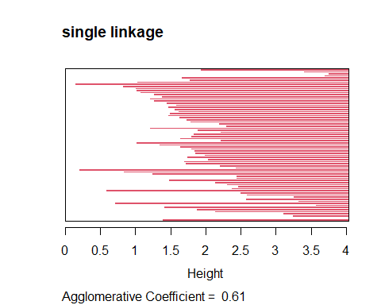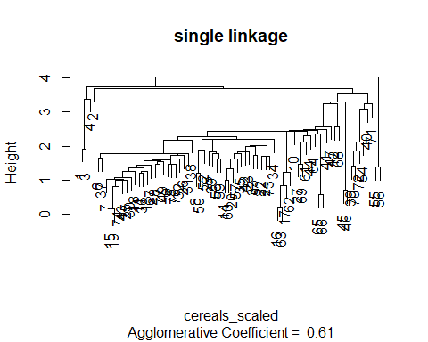

plot(agnes_complete, main = "complete linkage")

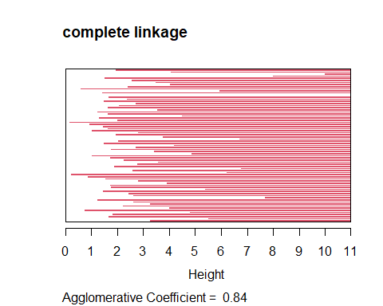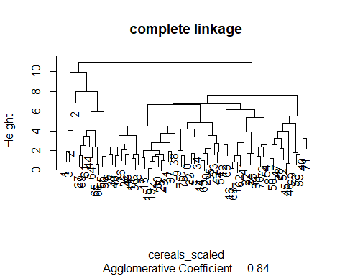

plot(agnes_average, main = "average linkage")

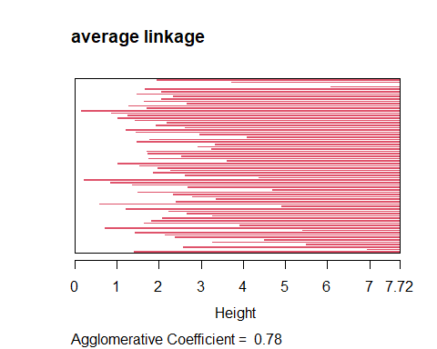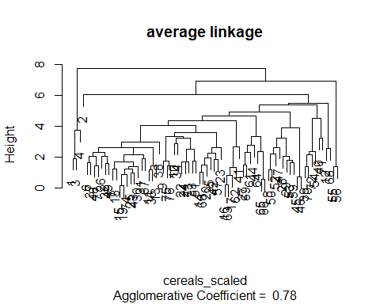

plot(agnes_ward, main = "ward's method")

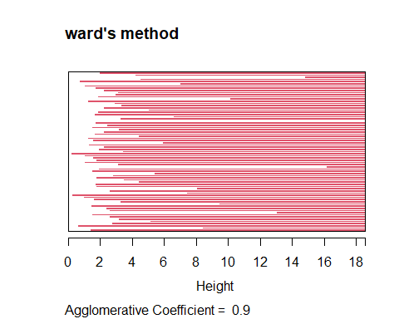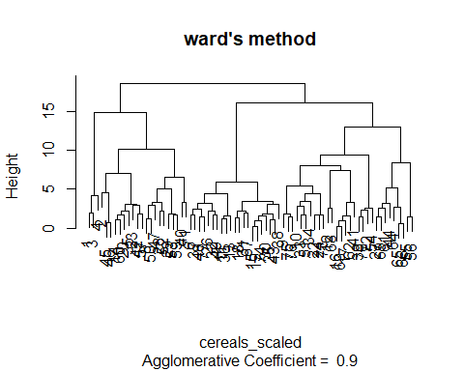

fviz_nbclust(cereals_scaled, FUN = hcut, method = "silhouette", k.max = 20)

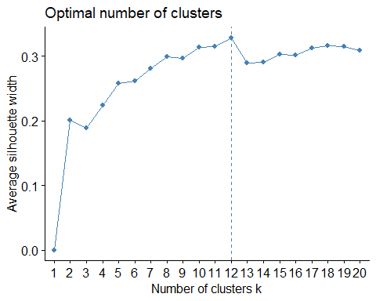

## choose k at elbow whcih is 2  
k <- 2  
clusters <- cutree(agnes_ward, k = k)  
table(clusters)

## clusters  
## 1 2   
## 23 51

set.seed(1)  
##create data partitions  
idx <- sample(1:nrow(cereals_scaled), size = 0.5 * nrow(cereals_scaled))  
partitionA <- cereals_scaled[idx, ]  
partitionB <- cereals_scaled[-idx, ]  
agnes_A <- agnes(partitionA, method = "ward")  
clusters_A <- cutree(agnes_A, k = k)  
centroids_A <- aggregate(partitionA, by = list(cluster = clusters_A), FUN = mean)  
centroids_matrix <- as.matrix(centroids_A[, -1])  
dist_Bcentroids <- proxy::dist(partitionB, centroids_matrix)  
clusters_B_1 <- apply(as.matrix(dist_Bcentroids), 1, which.min)  
agnes_B <- agnes(partitionB, method = "ward")  
clusters_B_2 <- cutree(agnes_B, k = k)  
ari <- adjustedRandIndex(clusters_B_1, clusters_B_2)  
##clsuters are showing to be unstable, increased numbers of clusters will be  
## able to have more accurate data, but assingment asks for one "healthy"  
## and one "unhealthy" group  
print(paste("adjusted rand Index for cluster stability:", round(ari, 3)))

## [1] "adjusted rand Index for cluster stability: 0.244"

if (ari > 0.7) {  
 cat("Clusters are stable.\n")  
} else {  
 cat("Clusters may not be stable.\n")  
}

## Clusters may not be stable.

##show the avg data between both clusters  
totaldata <- aggregate(cereals_num, by = list(cluster = clusters), mean)  
print(totaldata)

## cluster calories protein fat sodium fiber carbo sugars  
## 1 1 116.0870 3.260870 1.7826087 157.8261 4.130435 13.0000 8.608696  
## 2 2 102.9412 2.176471 0.6470588 164.4118 1.294118 15.5098 6.431373  
## potass vitamins shelf weight cups rating  
## 1 172.17391 30.43478 2.913043 1.1500000 0.6526087 42.90285  
## 2 65.29412 28.43137 1.901961 0.9770588 0.8978431 42.13229

##show both cluster groupings  
cereals_clean$Cluster <- clusters  
for (i in 1:k) {  
 cat(paste0("Cluster ", i, ":\n"))  
 print(cereals_clean[cereals_clean$Cluster == i, "name"])  
 cat("\n")  
}

## Cluster 1:  
## [1] 100%_Bran   
## [2] 100%_Natural_Bran   
## [3] All-Bran   
## [4] All-Bran_with_Extra_Fiber   
## [5] Basic_4   
## [6] Clusters   
## [7] Cracklin'_Oat_Bran   
## [8] Crispy_Wheat_&_Raisins   
## [9] Fruit_&_Fibre_Dates,_Walnuts,_and_Oats  
## [10] Fruitful_Bran   
## [11] Great_Grains_Pecan   
## [12] Just_Right_Fruit_&_Nut   
## [13] Life   
## [14] Muesli_Raisins,_Dates,_&_Almonds   
## [15] Muesli_Raisins,_Peaches,_&_Pecans   
## [16] Mueslix_Crispy_Blend   
## [17] Nutri-Grain_Almond-Raisin   
## [18] Oatmeal_Raisin_Crisp   
## [19] Post_Nat._Raisin_Bran   
## [20] Quaker_Oat_Squares   
## [21] Raisin_Bran   
## [22] Raisin_Nut_Bran   
## [23] Total_Raisin_Bran   
## 77 Levels: 100%_Bran 100%_Natural_Bran All-Bran ... Wheaties_Honey_Gold  
##   
## Cluster 2:  
## [1] Apple_Cinnamon_Cheerios Apple_Jacks   
## [3] Bran_Chex Bran_Flakes   
## [5] Cap'n'Crunch Cheerios   
## [7] Cinnamon_Toast_Crunch Cocoa_Puffs   
## [9] Corn_Chex Corn_Flakes   
## [11] Corn_Pops Count_Chocula   
## [13] Crispix Double_Chex   
## [15] Froot_Loops Frosted_Flakes   
## [17] Frosted_Mini-Wheats Fruity_Pebbles   
## [19] Golden_Crisp Golden_Grahams   
## [21] Grape_Nuts_Flakes Grape-Nuts   
## [23] Honey_Graham_Ohs Honey_Nut_Cheerios   
## [25] Honey-comb Just_Right_Crunchy__Nuggets  
## [27] Kix Lucky_Charms   
## [29] Maypo Multi-Grain_Cheerios   
## [31] Nut&Honey_Crunch Nutri-grain_Wheat   
## [33] Product_19 Puffed_Rice   
## [35] Puffed_Wheat Raisin_Squares   
## [37] Rice_Chex Rice_Krispies   
## [39] Shredded_Wheat Shredded_Wheat_'n'Bran   
## [41] Shredded_Wheat_spoon_size Smacks   
## [43] Special_K Strawberry_Fruit_Wheats   
## [45] Total_Corn_Flakes Total_Whole_Grain   
## [47] Triples Trix   
## [49] Wheat_Chex Wheaties   
## [51] Wheaties_Honey_Gold   
## 77 Levels: 100%_Bran 100%_Natural_Bran All-Bran ... Wheaties_Honey_Gold

##healthy cereal cluster 1(subjective data, i believe more vitamins and fiber outweighs   
##calorie and sugar quantities)  
print(cereals_clean[cereals_clean$Cluster == 1, "name"])

## [1] 100%_Bran   
## [2] 100%_Natural_Bran   
## [3] All-Bran   
## [4] All-Bran_with_Extra_Fiber   
## [5] Basic_4   
## [6] Clusters   
## [7] Cracklin'_Oat_Bran   
## [8] Crispy_Wheat_&_Raisins   
## [9] Fruit_&_Fibre_Dates,_Walnuts,_and_Oats  
## [10] Fruitful_Bran   
## [11] Great_Grains_Pecan   
## [12] Just_Right_Fruit_&_Nut   
## [13] Life   
## [14] Muesli_Raisins,_Dates,_&_Almonds   
## [15] Muesli_Raisins,_Peaches,_&_Pecans   
## [16] Mueslix_Crispy_Blend   
## [17] Nutri-Grain_Almond-Raisin   
## [18] Oatmeal_Raisin_Crisp   
## [19] Post_Nat._Raisin_Bran   
## [20] Quaker_Oat_Squares   
## [21] Raisin_Bran   
## [22] Raisin_Nut_Bran   
## [23] Total_Raisin_Bran   
## 77 Levels: 100%_Bran 100%_Natural_Bran All-Bran ... Wheaties_Honey_Gold